Connected app: https://graingerplc.my.salesforce-setup.com/lightning/setup/ConnectedApp/page?address=%2F_ui%2Fcore%2Fapplication%2Fforce%2Fconnectedapp%2FForceConnectedApplicationPage%2Fd%3FapplicationId%3D06PNz000001V6er
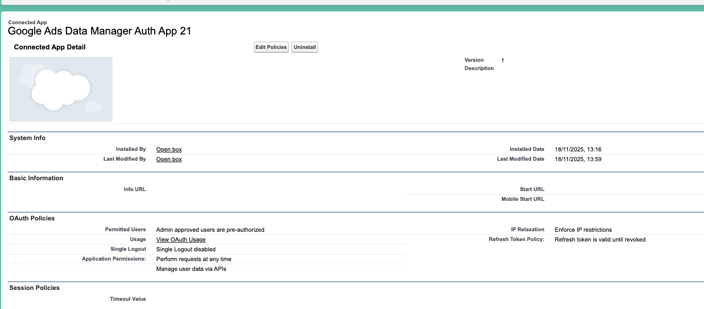

Permission granted via permission set as below:

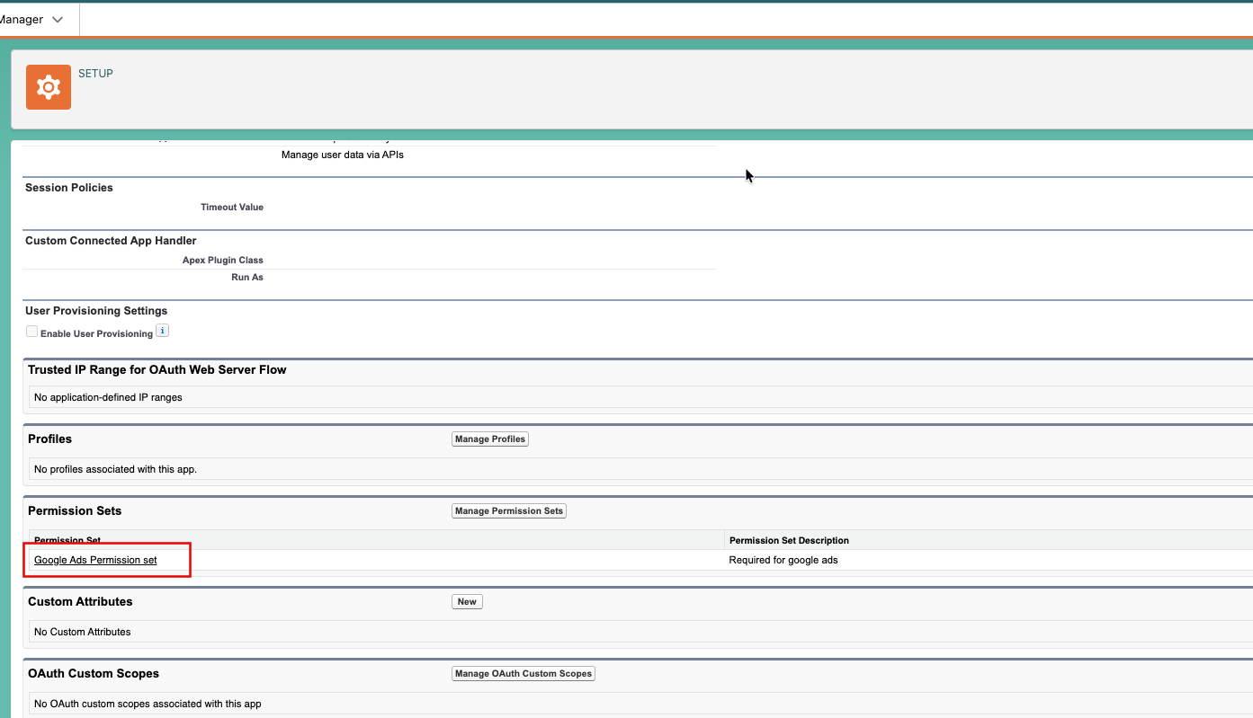

Connected app user: https://graingerplc.my.salesforce-setup.com/lightning/setup/ManageUsers/page?address=%2F005Nz00000I15cnIAB%3Fnoredirect%3D1%26isUserEntityOverride%3D1%26retURL%3D%252Fsetup%252Fhome

User is added to permission set as below
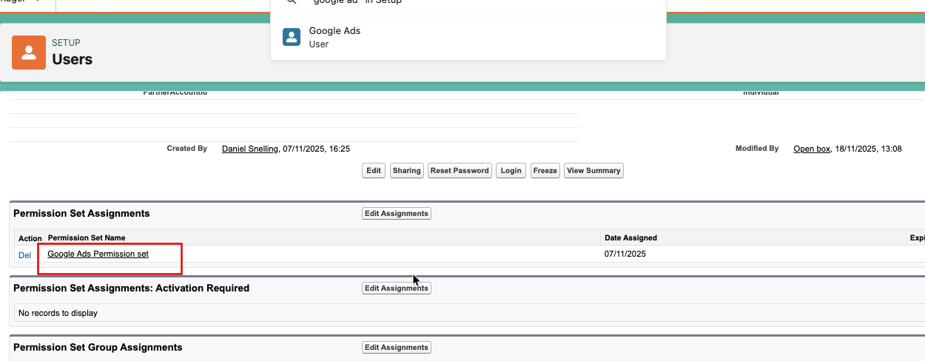

When trying to connect Google Ads to Salesforce using the native Google integration, the process fails as below: (see the URL where it shows “https://graingerplc.my.salesforce.com/setup/secur/RemoteAccessErrorPage.apexp?error=invalid_client&error_description=app+must+be+installed+into+org)

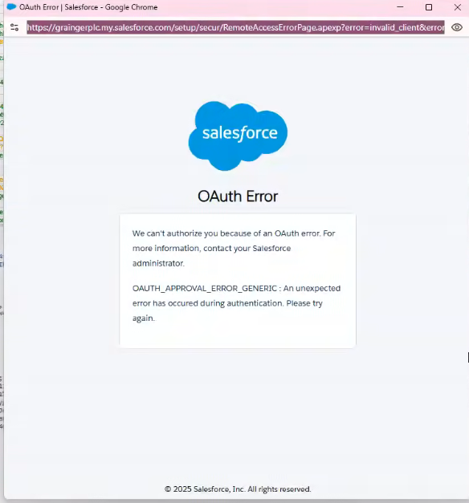

This app is already installed and the user has access to the app.

